**Individual** [**e-Portfolio**](https://vasilisalook.github.io/modules/2023/05/30/my-fifth-module.html) **Submission**

**(Intelligent Agents May 2023)**

**Unit 1. Dark sides of Agent-based systems**

We had started this module with a remarkable discussion on the topic of Intelligent Agents in social media. During our conversation with fellow students about positive impact of agent-based systems like chatbots, sentiment analysis, and recommender systems (Obadimu et al., 2019; Alsaeedi & Khan, 2019), we also delved into the darker side of their development. These tools, while assisting companies in staying competitive by enhancing user engagement and satisfaction through the analysis of user behaviour, can also manipulate users (Shokeen & Rana, 2020).

Intelligent Agents on social media, striving to keep users constantly scrolling, have caused problems such as information overload, doom-scrolling, shortened attention spans, sexualization of kids, polarisation, and the spread of fake news (Harris & Raskin, 2023).

Alberto Castro (2023) highlighted that recommender systems still have room for improvement, particularly in sensitive areas like data privacy. He provided an example of “bad” targeting, where a customer discovered about his young daughter’s pregnancy through targeted ads.

Our discussion also touched on bias within recommender systems, which can lead to discrimination against certain user groups and the creation of prejudicial filter bubbles. "One may argue that using a movie recommender is relatively harmless, but personalized movie preference data comes with a risk of de-anonymisation. Ramakrishnan et al. (2001) were able to reveal even political stances for individual users from seemingly innocent data sets." (Calero, 2019).

At the conclusion of our conversation, Anastasia Rizzo (2023) posed thought-provoking questions. For instance, how can we strike a balance between the benefits of these agents and user safety and autonomy? What measures can companies and developers implement to mitigate the negative impacts and foster responsible AI deployment?

**Unit 2. FOL for Linguists**

As a linguist, I have devised a primitive visual scheme for transforming sentences from English natural language to First-order language in order to grasp the main idea on my own. First-order logic offers greater expressive power than Propositional logic (Gurevich & Shelah, 1986), which is also utilised in the field of computing. I find it fascinating and intellectually stimulating to interpret information from “English human” format to “English computer” format. I believe this is of great importance because individuals can be represented as agents in systems too.

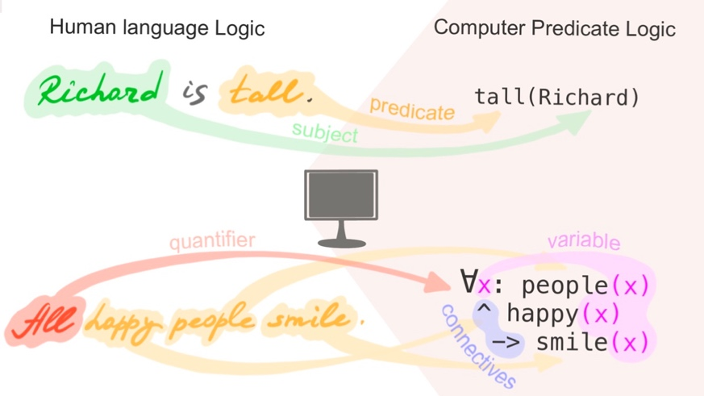

Understanding the fundamental terms and rules of this logic is crucial. For example, a predicate is a component of a sentence that contains a verb or makes a statement about the subject (where the subject is an attribute represented as a piece of information enclosed in brackets in computing).

I consider this point to be where programming becomes a highly creative process. To write a sentence like “It is rained” as *weather(X, rain*), one needs to exercise creativity. Another intriguing observation is that pronouns such as I, it, you, he, and she can be regarded as variables in natural language. My insight is that a human language itself is a program, albeit a highly layered and sophisticated one.

**Units 3-4. Hybrid Agents**

The agent architectures turned out to be one of the most challenging topics for me throughout the entire educational process because the level of abstraction here seemed too high. It felt like I needed visualisations for every concept.

I realised that hybrid agents are something between symbolic (or deliberative) reasoning agents and reactive agents. They attempt to balance proactiveness with reactivity (Beckley, 2023).

However, I have heard the term “hybrid intelligent agent” used in a slightly different context, as I illustrated below (Yakovlev, 2019).

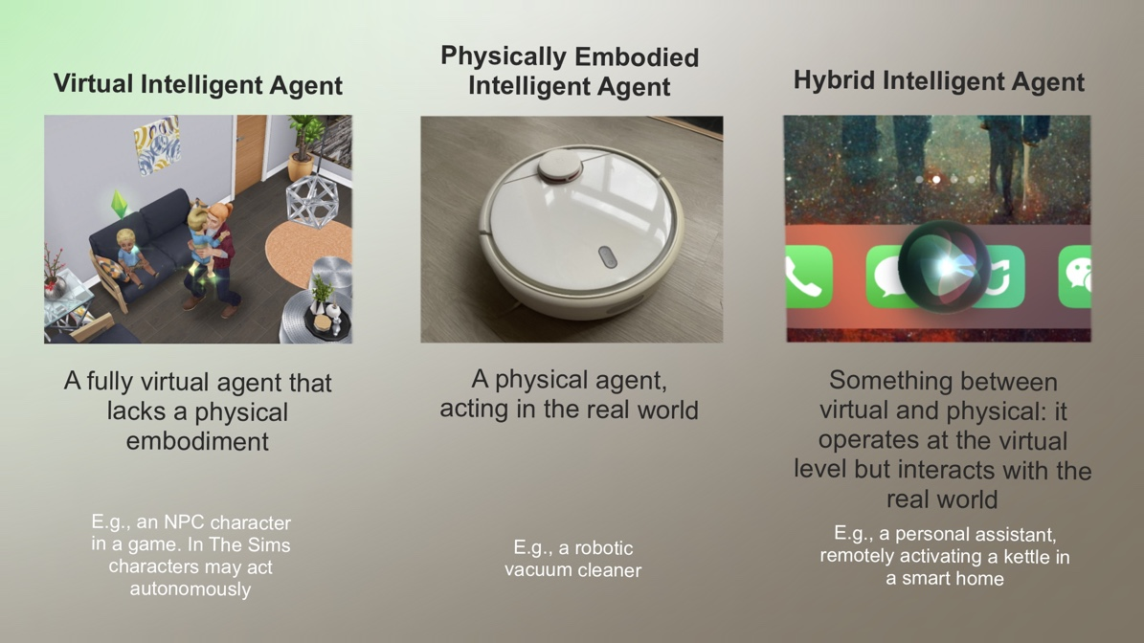

**Unit 5. Development Team Project**

To be honest, I found it quite challenging to work on the development team project, particularly when it came to distinguishing between a multi-agent system (Wooldridge, 2009), a single-agent system, and a distributed system with autonomous objects.

According to Odell (2002), agents exhibit autonomy because they can react to their environment and follow instructions. For instance, agents have the ability to both “say ‘No’ and ‘Go’. Agents engage in a negotiation-like process, exchanging information and incorporating it into their existing knowledge acquired from the environment. Based on this knowledge, agents make decisions on how to proceed.

Another challenge we encountered was the usage of Knowledge Query and Manipulation Language (KQML). This widely used agent communication language (ACL) allows agents with different goals and ontologies to share information while pursuing their individual objectives (Finin at al., 1994).

However, at the beginning, our team had a vague understanding of how to appropriately implement KQML in Python. As a result, we decided to start with creating a single-agent system with two modules to address the needs of the Digital Forensics domain for a hypothetical detective agency. The system’s purpose was to locate specific file types within a file system, archive them, and transmit the results for further analysis.

We proposed implementing this task using a single-agent system, considering that intelligent agents possess key characteristics such as autonomy, reactivity, proactivity, adaptability, and the ability to communicate and coordinate with other agents (Kendrick et al., 2016). During the evaluation, the tutor provided positive feedback, stating that the report was well-presented and covered the topic in sufficient detail. However, they advised us to provide explanations for the choices we made and to enhance our focus on critical analysis.

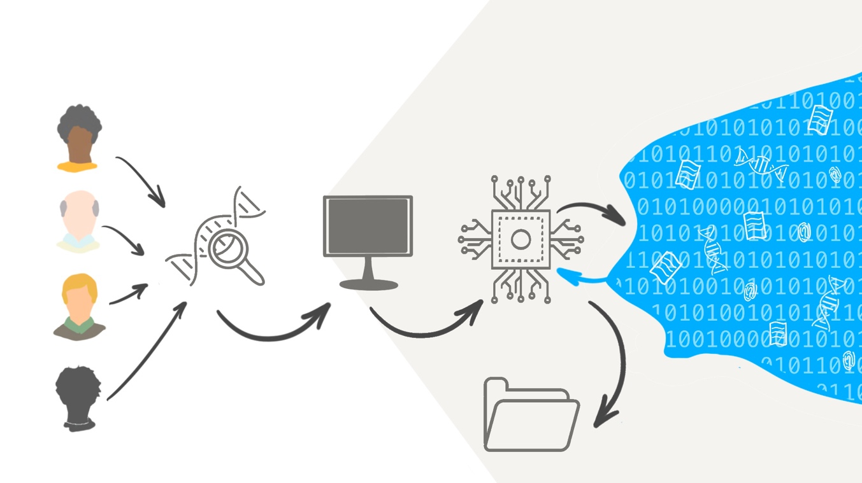

**Unit 6. Agent communication languages (ACLs) and agent system discussion**

In this module, we have had the best and the most engaging discussion with my fellow students throughout my entire time studying at the University of Essex. The discussion came at a crucial moment when my team and I were trying to differentiate between a multi-agent system and a single-agent system. I warmly invite you to read the Collaborative Discussion Summary, which includes a list of useful references.

We have discussed the ways of communication in agent systems, contrasting various possible languages and approaches. Knowledge Query and Manipulation Language (KQML) was a highly popular agent communication language about 20-30 years ago, which is probably excellent for familiarising oneself with the topic. Nowadays, another option called FIPA-ACL seems to be more widely adopted (Gan et al., 2019).

Toor (2023) proposed object-oriented programming (OOP) methods such as Java or Python to bridge the gap between ACLs and other programming languages. I believe this is an obvious solution because OOP is a programming paradigm that utilises the concepts of Classes and Objects, which are also employed in application programming interfaces (APIs). APIs, in turn, have already filled this communication gap in complex systems. For instance, thanks to APIs, we are able to engage in online shopping on Amazon.

Feaviour (2023) noted that Amazon is more of a distributed system than a multi-agent system, which may not necessarily require the features that warrant the use of an ACL. However, I believe that if the service conducts real-time data analysis and provides personalised product offerings based on the consumer's previous preferences, or even if the web-shopping is connected to Alexa, the entire process can be considered as a multi-agent system.

Actually, Amazon uses a multi-agent system to manage the cloud provider's resources while taking into account the customers' quality of service requirements (Al-Ayyoub et al., 2015).

Castro (2023) highlighted that although communication between intelligent agents typically involves transactional requests and responses through APIs, both the client and server must have prior knowledge of the payload used for communication. However, in certain scenarios, intelligent agents may be unaware of the existence of other agents. Nevertheless, they should possess the ability to communicate effectively.

Adeniyi (2023) added that comparing method invocation within the same program, ACLs offer numerous advantages. However, it is important to acknowledge that distributed systems utilising the object-oriented paradigm can overcome these limitations by utilising frameworks, implementing APIs for cross-language communication (such as JSON), or employing asynchronous communication through queues.

**Unit 7. Natural Language Processing (NLP)**

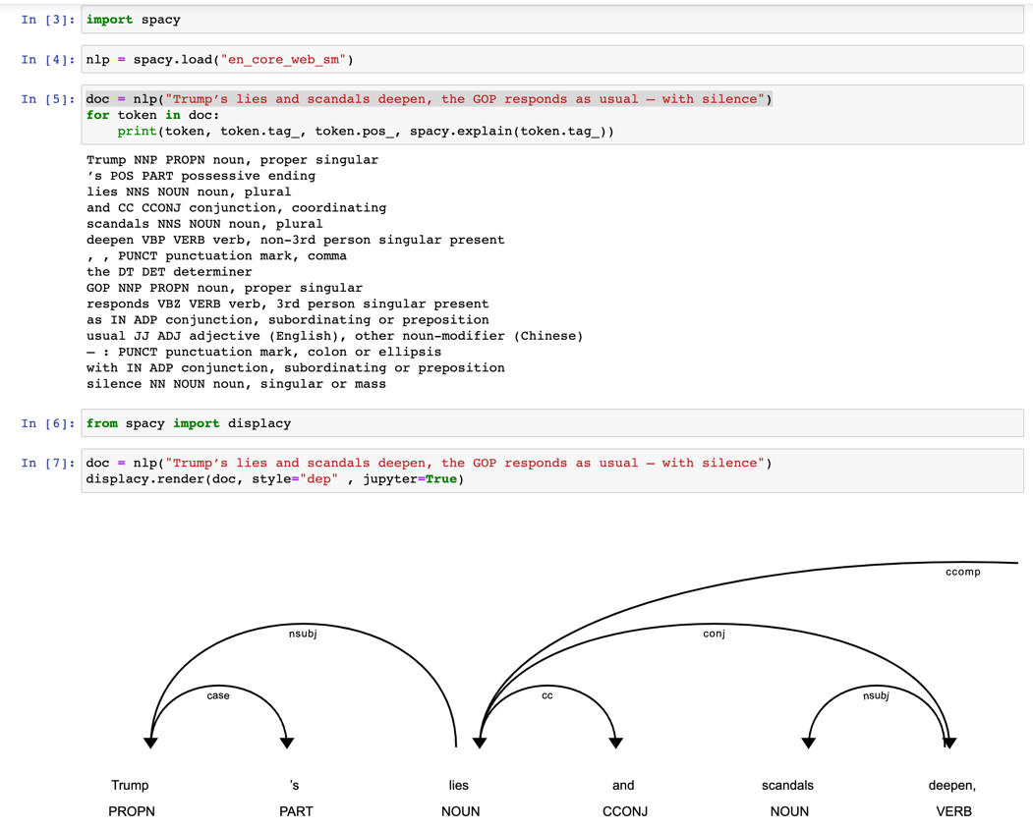

As a linguist, I find natural language processing (NLP) branch of computer science to be incredibly fascinating. I enjoy working with the spaCy library, which offers a wide range of linguistic annotations for sentences and enables faster analysis than searching through dictionaries.

Another practical application of NLP is utilising machine learning (ML) to analyse whether comments in the Russian language contain toxic content (I did it last year during ML module).

I will encounter numerous tasks in the context of NLP while working on my Capstone project (the project is around news texts and bias detection methods).

However, one of the major challenges in NLP is the scarcity of sufficient training data (Ain et al., 2017). This has led to the emergence of pre-trained BERT models, which are based on NLP tasks such as Masked Language Modelling and Next Sentence Prediction anyway.

**Unit 8. Creating Parse Trees**

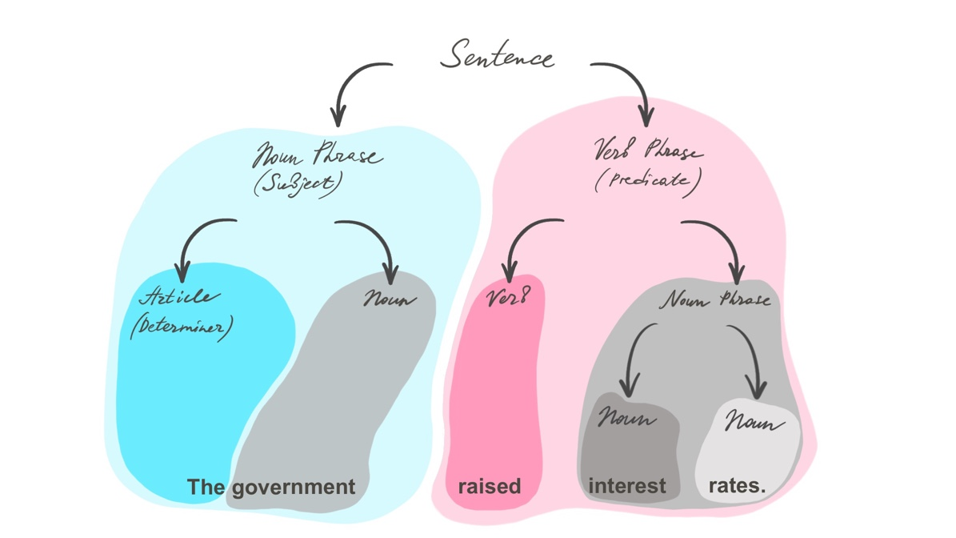

Parse tree shows the relationships between a specific sentence and the grammar concepts (Sowa & Way, 1986). Again, as a linguist, I find this topic very familiar. It’s great to see that programmers utilise the same concepts, such as “part of speech” (POS) or “grammatical relations.” Decades of philological research by humans have been incredibly helpful for computer science.

When I first started studying methods like lemmatisation (reducing a word to its root form), I had concerns about cutting off the end of words because it may remove important contextual information (such as distinguishing between one dog or many dogs). However, I soon realised that the major disadvantage of lemmatisation algorithms is their slower speed compared to stemming algorithms. (Balakrishnan & Lloyd-Yemoh, 2014). You are welcome to check other parse tree pictures in my e-Portfolio.

**Unit 9. Deep Learning**

We had another engaging discussion on new Deep Learning tools, such as Dall-E AI and ChatGPT. In addition to the news emerging from Hollywood regarding creator class strikes (Lukashevich, 2023), we still face the unresolved issue of intellectual property rights.

The generated content is created by a large language model trained on vast amounts of data, which may include copyrighted material. For instance, the U.S. lacks a legislative policy that addresses the attribution of copyrights for AI-produced works (Hristov, 2020).

Feaviour (2023) has posed questions regarding whether the original sources should be regarded as mere "inspiration" rather than direct copies and who holds the liability in the case of copyright infringement.

However, it was also pointed out by Feaviour (2023) that the US Copyright Office has recently released guidance stating that content produced solely by AI, without significant modifications by a human, is not eligible for copyright protection.

I added, that The United Kingdom is unique among all countries in recognising "computer-generated works" within its domestic law, as highlighted by Lucchi (2023). By broadening the scope of authorship, the UK takes a practical approach to address this issue. Intellectual property laws, as emphasised by GOV.UK (2022), serve as an incentive for scholars, inventors, and businesses to invest their time and resources in innovative pursuits with confidence.

As Rizzo (2023) pointed out, the ethical considerations surrounding AI-generated content are vital issues that require attention. It is necessary for AI to become more transparent and potentially subject to improved regulation. For instance, I propose that relevant information should be displayed alongside pictures or videos, similar to warnings on cigarette packs.

**Unit 10. Deep Learning in action**

I believe that analysing social media with Deep Learning has already impacted society and will continue to do so even more. Let us consider an example - the Deep Learning algorithms to detect suicidal warnings through posts on social network platforms.

On the one hand, it can have a significant impact on society, especially in relation to mental health support and suicide prevention. Social media contain deliberate and unintended self-disclosures, which can serve as a source of features for psychological interpretations using Deep Learning algorithms, such as CNNs for images or RNNs for short texts (Dudău, 2021; Ji et al., 2020). Through the analysis of visual content shared by users, this technology aims to identify potential signs of distress and offer early intervention to individuals at risk.

A possible structure for the methodology and technology section could be as follows:

**Data Collection —>** **Annotation and Labelling —>** **Training of the Deep Learning Model —>** **Detection and Alert System**

When a warning is detected, an alert is generated and sent to the appropriate authorities or designated support networks for timely intervention.

However, the psychology of suicide is inherently complex. As an illustration, consider the social media posts of Chester Bennington, the singer of Linkin Park, who shared photos of himself smiling before he tragically took his own life. His wife later revealed that there were subtle indications of his distress, including “the hopelessness, the change of behaviour, isolation” (King, 2018). Scholars have acknowledged the presence of a "contradictory relationship between the usage of verbs and suicidal ideation." (De Choudhury et al., 2016). Therefore, relying solely on a single technology such as face emotion recognition is insufficient. Instead, a comprehensive set of features should be incorporated into a well-trained and adaptable deep learning model.

At the same time, we must consider ethical considerations. Let us consider a hypothetical scenario where we can predict potential suicides by analysing a user's profile with a precision rate of 70-90%. What should be the subsequent course of action? Any related application ought to be developed as a supplementary tool to existing mental health services, operating in conjunction with mental health professionals and crisis helplines.

By the way, I have personally experienced the influence of AI while writing this text, as Google provided me with a prominent helpline number for assistance when I searched for information using the word “suicide”. It is worth noting that only Google Scholar appropriately handles queries related to suicide.

**Unit 11. Team Project 2 (Presentation)**

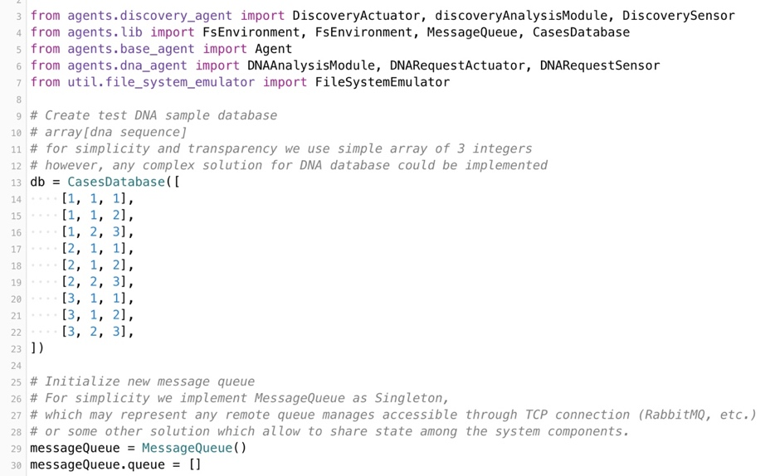

This time, in my opinion, the project appears to be more challenging. We began with the previous team project as a starting point, but we ambitiously decided to enhance it by introducing a new agent, transforming from a single-agent system to a multi-agent system. We implemented the entire architecture using both MessageQueue for communication and an agent communication language (ACL) to facilitate agent interactions.

Although MessageQueue is not an ACL and not specifically designed for agent communication, it can still serve as a communication mechanism within a multi-agent system. The decision to incorporate both communication variants was not an easy one and probably not the best, but we believed it was the most suitable approach.

Relying solely on ACLs carries certain risks in agent communication, such as potential delays in negotiation if they cannot be conducted swiftly. "Despite benefits of reaching an agreement, agent negotiations process is presumed as a costly and time-consuming practice" (Mahdi et al., 2010)

We also encountered challenges with the frequent renaming and "rebranding" of our two agents to provide clearer explanations of their roles. This process was time-consuming, requiring us to update their names across various related files, including code, README, pictures, and diagrams, to ensure consistency. As a next step, I propose initiating the naming process from scratch. Given the complexity of the agent system, it is more beneficial to start anew rather than attempting to fix the previous project.

By the way, I want to note that my team members are brilliant. Despite the significant time zone differences between China, Ukraine, and Mexico, we have managed to contribute effectively and support each other in every decision.

**Unit 12. Skill Matrix and Action Plan**

I undertook this module concurrently with the Research Methods and Professional Practice module. Feel free to review the skill matrix and action plan from [there](https://vasilisalook.github.io/modules/2023/06/21/my-sixth-module.html).

**References**

Ain, Q.T., Ali, M., Riaz, A., Noureen, A., Kamran, M., Hayat, B. and Rehman, A., 2017. Sentiment analysis using deep learning techniques: a review. *International Journal of Advanced Computer Science and Applications, 8*(6).

Al-Ayyoub, M., Jararweh, Y., Daraghmeh, M. & Althebyan, Q. (2015) Multi-agent based dynamic resource provisioning and monitoring for cloud computing systems infrastructure. *Cluster Computing, 18*, pp.919-932.

Alsaeedi, A. & Khan, M.Z., 2019. A study on sentiment analysis techniques of Twitter data. International Journal of Advanced Computer Science and Applications, 10(2).

Amrani, N.E.A., Youssfi, M., Bouattane, O. & Abra, O.E.K. (2020) Interoperability between heterogeneous multi-agent systems recommended by fipa: Towards a weakly coupled approach based on a network of recurrent neurons of the lstm type. In *2020 3rd International Conference on Advanced Communication Technologies and Networking (CommNet) (pp. 1-6). IEEE.*

Balakrishnan, V. & Lloyd-Yemoh, E. (2014) Stemming and lemmatization: A comparison of retrieval performances.

Buckley, O. (2023) Agent Architectures [Lecturecast]. Intelligent Agents May 2023. University of Essex Online.

Calero Valdez, A. & Ziefle, M. (2019) The users' perspective on the privacy-utility trade-offs in health recommender systems. *International journal of human-computer studies.* [Online] 121108–121.

Castro, A. (2023) Initial Post. Collaborative Discussion 1: Agent Based Systems in Intelligent Agents May 2023 module. The University of Essex Online. Available from: https://www.my-course.co.uk/mod/forum/discuss.php?d=156865 [Accessed 13 May 2023].

Castro, A., Feaviour, L., Dudkin, M., Rizzo, A., Lukashevich V. & Adeniyi, S. (2023) Initial post [Collaborative Learning Discussion 2]. Intelligent Agents May 2023. University of Essex Online. Available from: https://www.my-course.co.uk/mod/forum/discuss.php?d=163651 [Accessed 9 Jul 2023].

ChatGPT May 3 Version. Available from: chat.openai.com [Accessed 5 May 2023].

Darrow, R.M. (2023) The future of AI is the market. In *Artificial Intelligence and Machine Learning in the Travel Industry: Simplifying Complex Decision Making* (pp. 177-182). Cham: Springer Nature Switzerland.

De Choudhury, E. Kiciman, M. Dredze, G. Coppersmith & M. Kumar (2016) Discovering shifts to suicidal ideation from mental health content in social media, in In *Proceedings of the 2016 CHI Conference on Human Factors in Computing Systems*, pp. 2098–2110.

Dudău, D.P. (2021) Harnessing the Power of Data Science to Grasp Insights About Human Behaviour, Thinking, and Feeling from Social Media Images. *Pathways Between Social Science and Computational Social Science: Theories, Methods, and Interpretations*, pp.95-122.

Feaviour, L. (2023) Initial Post [Collaborative Learning Discussion 3]. Intelligent Agents May 2023. University of Essex Online. Available from: https://www.my-course.co.uk/mod/forum/discuss.php?d=168724 [Accessed 15 Jul 2023].

Finin, T., Fritzson, R., McKay, D. & McEntire, R. (1994) ‘KQML-a language and protocol for knowledge and information exchange’ 13th International Distributed Artificial Intelligence Workshop. Seattle, WA, 28-30 July. Association for the Advancement of Artificial Intelligence (AAAI). 93-103.

Finin, T. & Labrou, Y. (2002) Theory and Practice of Agent Communication Languages (Presentation). Available from: https://redirect.cs.umbc.edu/~finin/talks/691m.pdf [Accessed 16 Jun 2023].

Gan, K. S., Anthony, P., Chin, K. O. & Hamdan, A. R. (2019) 'Enforcing Social Semantic in FIPA-ACL Using SPIN', Agents and Multi-agent Systems: Technologies and Applications. St. Julians, Malta. Manhattan: Springerlink.

Gurevich, Y. and Shelah, S., 1986. Fixed-point extensions of first-order logic. *Annals of pure and applied logic, 32*, pp.265-280.

Harris, T. & Raskin, A. (2023) The AI Dilemma. Center for Humane Technology YouTube channel. Available from: https://www.youtube.com/watch?v=xoVJKj8lcNQ [Accessed 5 May 2023].

Hristov, K. (2020) Artificial intelligence and the copyright survey. Available from: https://papers.ssrn.com/sol3/papers.cfm?abstract_id=3490458 [Accessed 30 Jun 2023].

Intellectual Property Office (2022) Artificial Intelligence and Intellectual Property: copyright and patents. GOV.UK, Available from:

https://www.gov.uk/government/consultations/artificial-intelligence-and-ip-copyright-and-patents/artificial-intelligence-and-intellectual-property-copyright-and-patents [Accessed 9 Jul 2023].

Ji, S., Pan, S., Li, X., Cambria, E., Long, G. & Huang, Z. (2020) Suicidal ideation detection: A review of machine learning methods and applications. *IEEE Transactions on Computational Social Systems, 8*(1), pp.214-226.

Kendrick, P., Hussain, A.J. & Criado, N. (2016) Multi-agent systems for dynamic forensic investigation. In *Intelligent Computing Theories and Application: 12th International Conference, ICIC 2016*, Lanzhou, China, August 2-5, 2016, Proceedings, Part I 12 (pp. 796-807). Springer International Publishing.

# King, A. (June 23, 2018) There were warning signs before Chester Bennington’s suicide, the Linkin Park singer’s widow says. *CNN*. Available from: https://www.cnn.com/2018/06/23/us/talinda-bennington-suicide-town-hall-cnntv/index.html [Accessed 11 Jul 2023].

Koltai, J., Kmetty, Z. & Bozsonyi, K. (2021) From Durkheim to machine learning: finding the relevant sociological content in depression and suicide-related social media discourses. *Pathways Between Social Science and Computational Social Science: Theories, Methods, and Interpretations*, pp.237-258.

Lucchi, N. (2023) ChatGPT: A Case Study on Copyright Challenges for Generative AI Systems. Available at SSRN 4483390.

Lukashevich, V., Feaviour, L. & Toor, A. (2023) Initial post: KQML for dummies. [Collaborative Learning Discussion 2]. Intelligent Agents May 2023. University of Essex Online. Available from: https://www.my-course.co.uk/mod/forum/discuss.php?d=163792 [Accessed 9 Jul 2023].

Lukashevich, V. (2023) Initial Post: AI and Art. [Collaborative Learning Discussion 3]. Intelligent Agents May 2023. University of Essex Online. Available from: https://www.my-course.co.uk/mod/forum/discuss.php?d=168564 [Accessed 15 Jul 2023].

Mahdi, G., Gouaïch, A. & Michel, F., 2010, May. Real-time Coordination Of Multi-Agent Systems: An Integrated View. In *AAMAS'10: Agents in Real-time and Dynamic Environments Workshop* (pp. N-A).

MSc AI E-Portfolio. Vasilisa Lukashevich's experience (2023) Intelligent Agents. The fifth module of the course. Available from: https://vasilisalook.github.io/modules/2023/05/30/my-fifth-module.html [Accessed 15 Jul 2023].

Obadimu, A., Mead, E., Al-Khateeb, S. & Agarwal, N. (2019) A comparative analysis of Facebook and Twitter bots. Conference: SAIS 2019 Proceedings. Available from: https://www.researchgate.net/publication/333676972_A_COMPARATIVE_ANALYSIS_OF_FACEBOOK_AND_TWITTER_BOTS [Accessed 5 May 2023].

Odell, J. (2002) Objects and agents compared. *Journal of object technology, 1*(1): 41-53.

Padovitz, A., Zaslavsky, A., Loke, S.W. & Tosic, M. (2004) Agent communication using publish-subscribe genre: architecture, mobility, scalability and applications. *Annals of Mathematics, Computing and Teleinformatics, 1*(2), pp.35-50.

Rizzo, A. (2023) Initial Post [Collaborative Learning Discussion 3]. Intelligent Agents May 2023. University of Essex Online. Available from: https://www.my-course.co.uk/mod/forum/discuss.php?d=169313 [Accessed 15 Jul 2023].

Shokeen, J. & Rana, C. (2020) A study on features of social recommender systems. *Artificial Intelligence Review, 53*, pp.965-988.

Sowa, J.F. & Way, E.C., 1986. Implementing a semantic interpreter using conceptual graphs. *IBM Journal of Research and Development, 30*(1), pp.57-69.

Wooldridge, M., 2009. An Introduction to MultiAgent Systems. 2nd ed. Chichester, UK: John Wiley & Sons.

Yakovlev, K. (2019) Intellectual agents. *PostNauka*. Available from: https://youtu.be/j2EyVI6PYWQ [Accessed 11 Jul 2023].